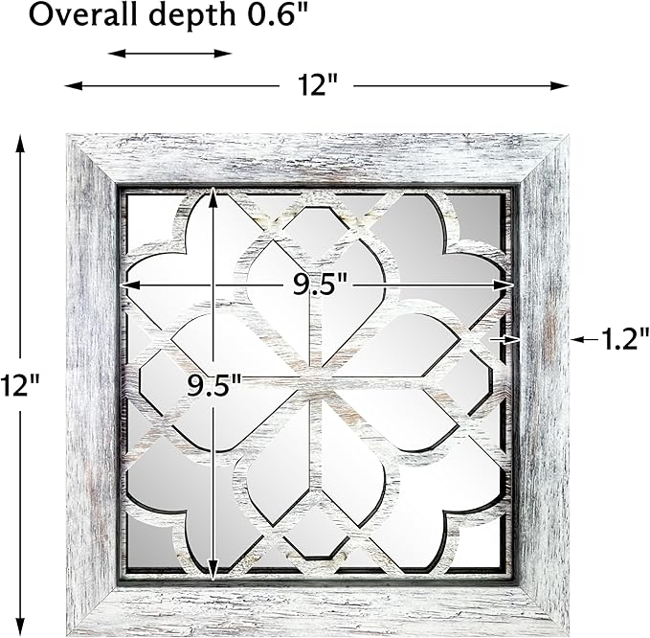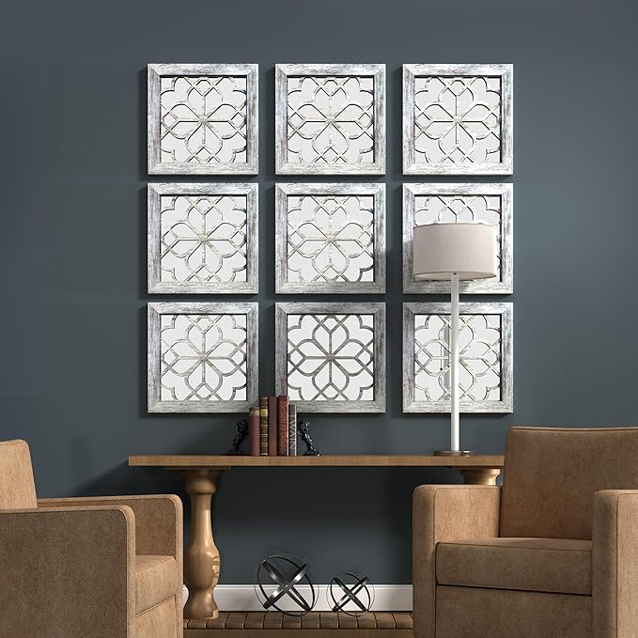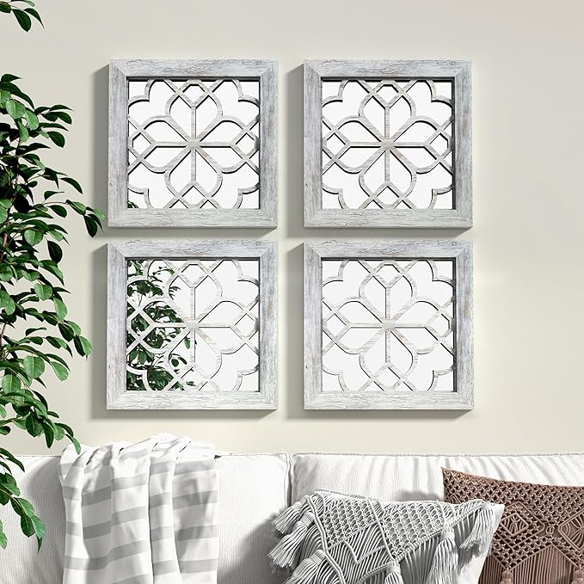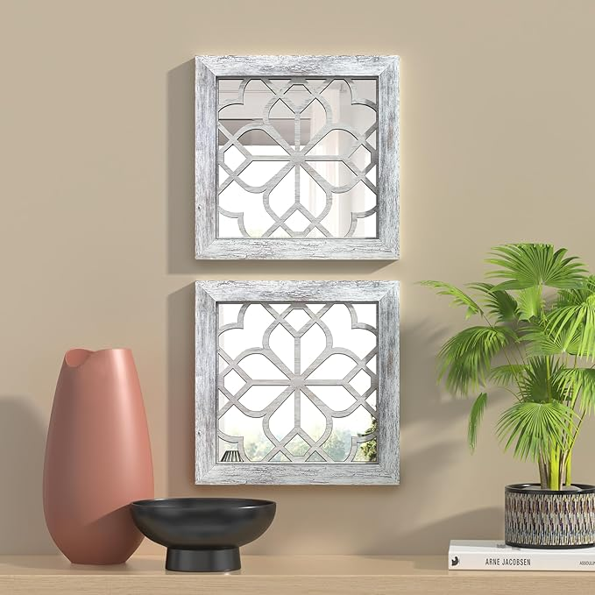

2 PCS Square Rustic Wall Mirror, Farmhouse Decorative White Wall Mirror for Bedroom Entry Living Room Dining Room (12”x12”)

**PRODUCT DESCRIPTION:**

|  |  |
| --- | --- |
| Brand | YOAYO |
| Room Type | Bedroom |
| Shape | Square |
| Product Dimensions | 12"L x 12"W |
| Frame Material | Glass, Engineered Wood, Polystyrene (PS) |

**About this item**

* WHAT YOU RECEIVE: You will receive 2 pieces of rustic wall decor mirrors. The rustic wooden frame combines with the beautiful fine carved shape in the middle, Unique pattern can satisfy your various decoration needs.
* EXQUISITE & DURABLE: The mirror consists of an MDF wooden frame, 3mm mirror and backing plate. The mirror is embedded in the frame and reinforced with a sturdy backing plate for great stability. It fits any vintage or modern wall decor is the perfect accent to your house.
* PERFECT SIZE: These window mirrors for wall decor measure 12"x12", it is not too big or too small. Perfect size for decoration living room, bedroom, dining room, entry way, hallways, etc.
* EASY TO HANG: This decorative mirror is designed to be hung on the wall and it can be hung horizontally or vertically. No any assembly, quite easy to hang on the wall. It gives a wonderful rustic look to any wall.
* PROFESSIONALLY PACKAGED: 2 PCS mirrors are packed in a cardboard box with polystyrene foam. We attach great importance to product quality and customer shopping experience, any problem please be free to contact us.